PB#3 SIMPLE-G-US demonstration
- In this video, we will explore how to use the SIMPLE-G-US online tool to do policy analysis related to nitrate leaching. I will use the experiments in policy brief #3 as examples to show some of the results reported. In PB#3, we explored four policies to sequentially introduce more conservation practices in order to reduce n loss. To see these experiments, first launch the tool and go to manage experiments and choose shared experiments. The four experiment names started with PB3, and use the corn soy model, will be the ones to be covered in this demo.
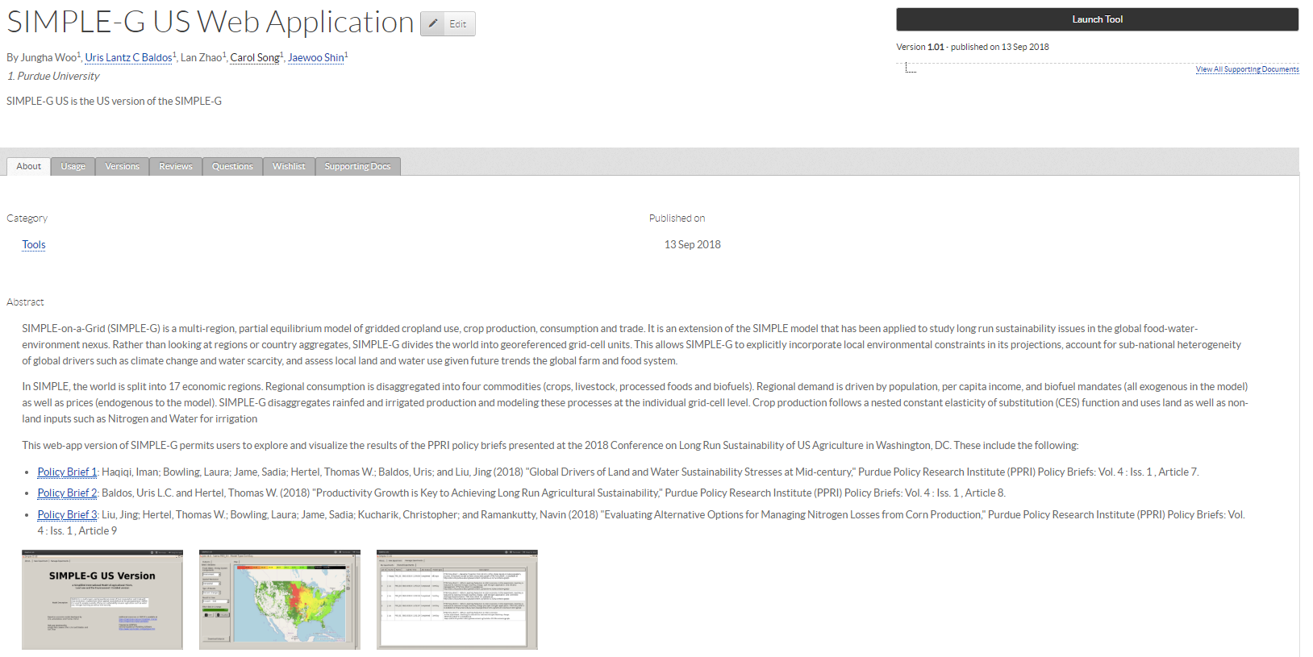
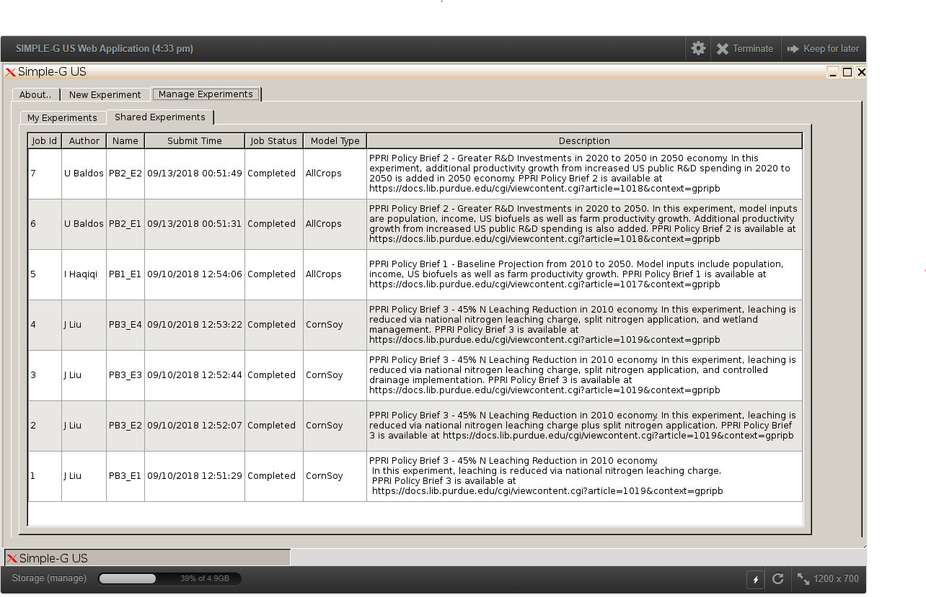
- Let’s look at experiment 1 first, which assumes the hypoxia task force goal will be achieved completely by reducing N application rate, while without improving N use efficiency. We can first look how the national 45% reduction of nitrate leaching is shared out by states. We can see that the absolute reduction takes place mainly in IA, IL, IN and NE.
- 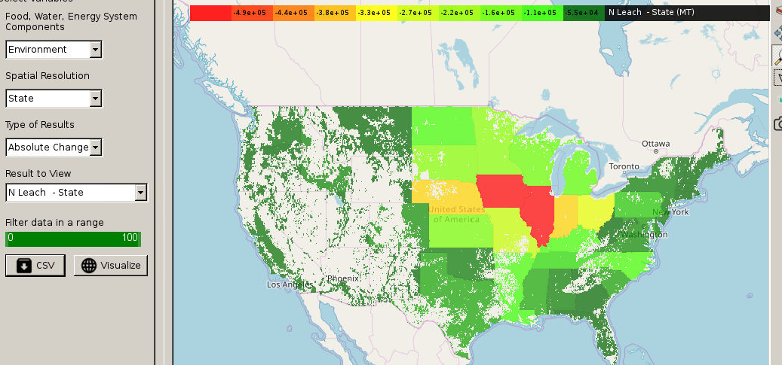

- This total leaching reduction requires less n to be used at the grid-cell level. This is the local response to the global driver. We can see that major reduction of n use is realized in the central Corn Belt area. You can also zoon in and hover over grids to see more information.

- 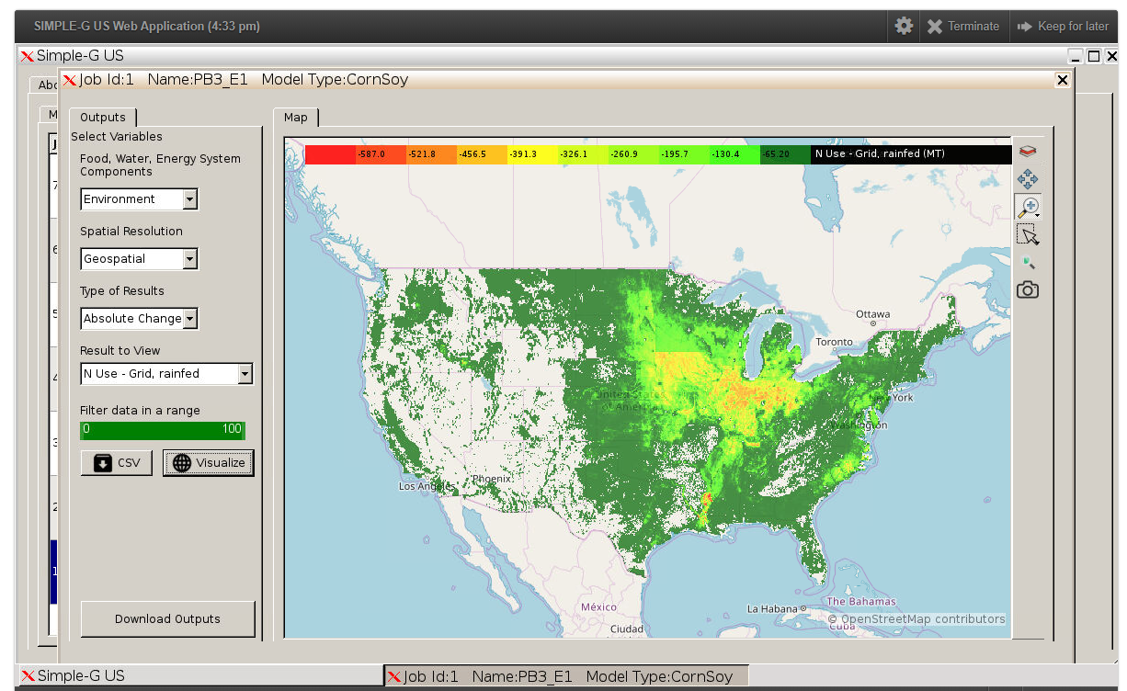

- Because less n fertilizer is used, this may negatively affect crop yields. At the grid cell level, we can see total reduction in rainfed output in thousand metric tons per grid cell. And also irrigated output in tons per grid cell. What is the impact at the national level? We can select regional level results, and update the map. So the national output will be reduce by 13%. So, achieving the goal completely by using less n fertilizer is a fairly expensive solution in terms of yield penalty and loss of output.
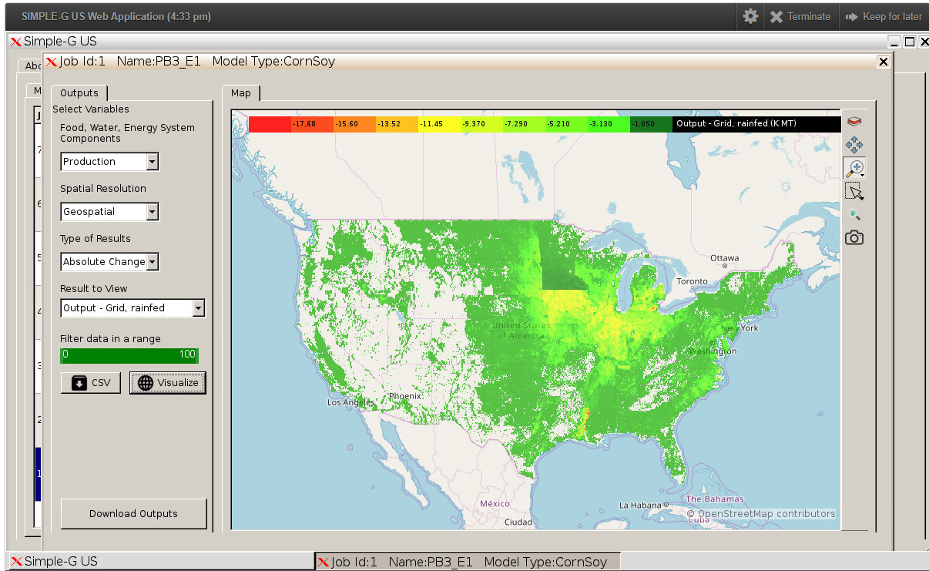
- Now, let’s look at an alternative policy, experiment #4. Instead of relying on single practice, in this experiment, multiple practices are combined to reduce n loss, including n rate reduction, improved n use efficiency and wetlands restoration to reduce n loss. Because wetland can remove a significant fraction of the n lost in soils, farmers don’t need to cut back fertilizer use by that much as in experiment #1. And also because fertilizer is more efficiently used, we expect yield penalty will be lower. To make it easier for comparison, I opened two windows side by side. LHS shows leaching reduction by state in experiment 1, and RHS shows experiment 4. We can see that the output reduction in experiment 4 is much more modest, only 1 to 2 percent.
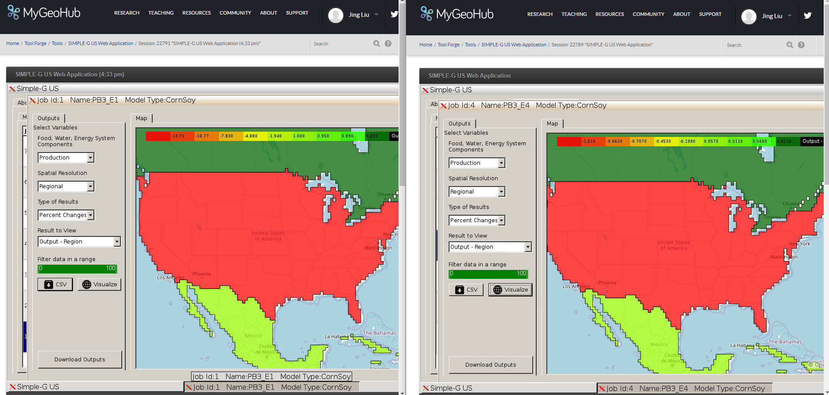
- In these two experiments, even if the goal is the same, that is to reduce n loss by 45 percent, the spatial pattern of the reduction is quite different. For example, at the state level, the major reduction in experiment 1 is in IA, IL, IN and NE. But in experiment 4, we see more contribution coming from NE and also from MN.
- 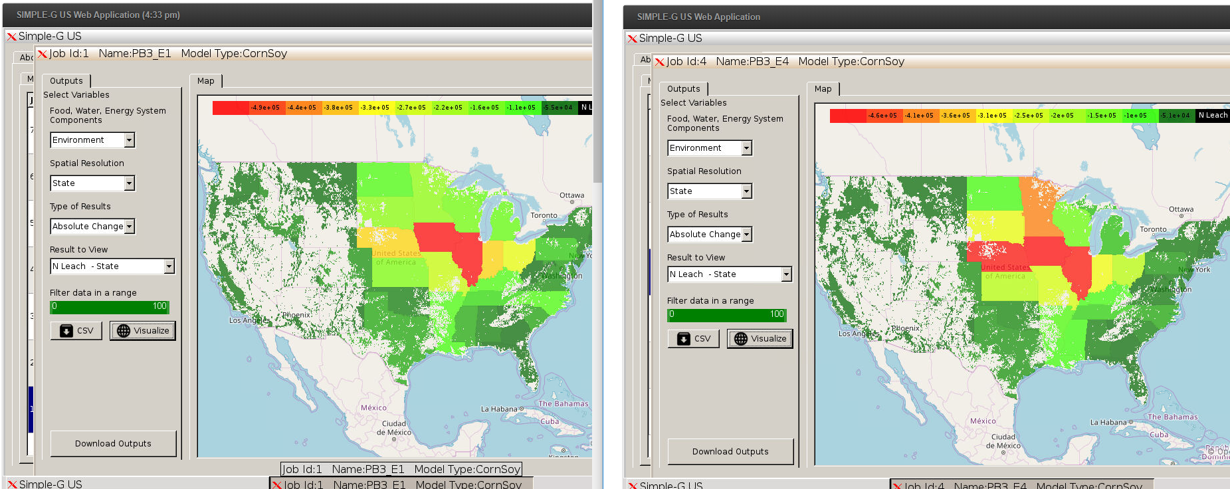

- We can also see more details at the disaggregated level by choosing leaching reduction at grid cells in both experiments. Now we can see clearly the difference. The pattern in experiment 4 is mainly driven by the feasibility of wetlands restoration and the effectiveness of removing N loss.
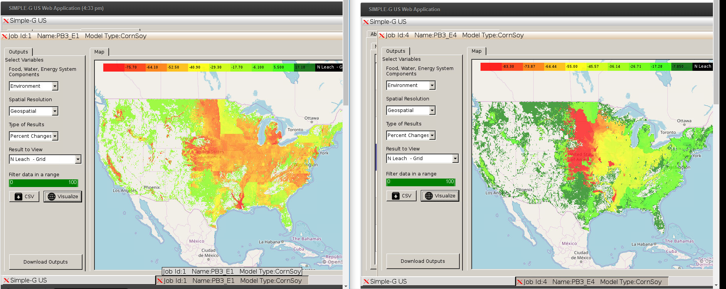
- This ends my demonstration of the tool. Thank you for your time. I hope that was helpful. Should you have any questions, please don’t hesitate to contact us.

