Global Drivers of Land and Water Sustainability Stresses at Mid-century, Exploring the results via the GeoHub
Iman Haqiqi, ihaqiqi@purdue.edu, September 2018
Thank you for listening to this video on how to use SIMPLE-G US web application on GeoHub. My name is Iman, and today we are going to look at some projection results on water and land use by the mid-century in the United States. It’s going to be useful if you want to explore the results of current studies in more details, it’s also useful for learning about the likely hotspots of water and land stresses. So we are going to look at how to launch the tool, load the experiment, and how to see the results.
First step, you need to go to the mygeohub.org/tools/simpleus
You will see the information about SUIMPLE-G-US. Click on launch tool icon on the right side of the screen.
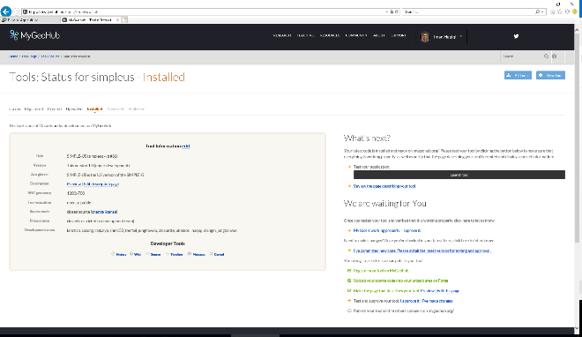
When the application is launched, you can see the interface. It has three main tabs. First tab is “About…” which has information about the tool and useful links. The second tab is designed for “New Experiment”. And the third tab includes your own experiments (if any) as well as shared experiments.
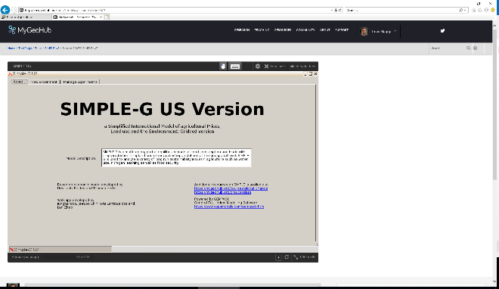
Click on the third tab and click again on “Shared Experiments”. Look at Name column. Select the experiment named “PB1_E1”. This is the experiment which shows the global impact of population, income, and productivity growth by 2050.
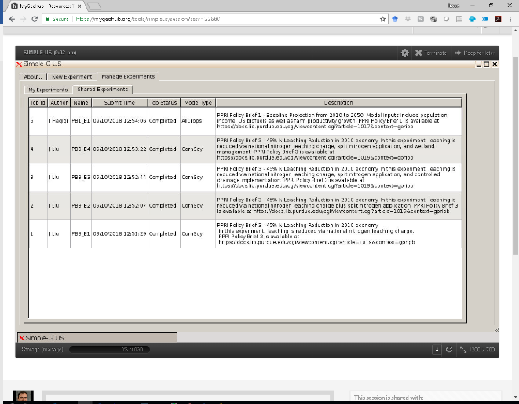
After clicking on the experiment, you will be directed to another page. On this page you can see the “map” navigation tools on the right and “output” variable selection panel on the left. You may also filter the extreme values using the green slider.
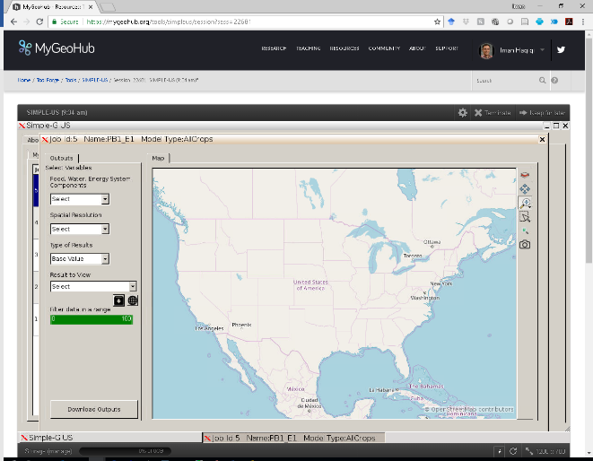

We will explore the impact of population, income, and productivity growth by 2050. Let’s take a look at some maps!
From the first drop-down menu, you may choose land, water, and production. Choose production.
From the second drop-down menu, you may choose what aggregation level you like including regional, state, geospatial (means gridded).
From the third, you may choose the base value of the variable (here 2010), updated value (2050), absolute change, and percentage change. It is important that starting points varies depending on the experiment.
From the last dropdown menu, you may choose output, yield, or prices (depending on availability at the selected resolution). Choose output –region. Now click on visualize. What you see is the percentage change in crop production due to population, productivity, and income growth from 2010 to 2050, with the biggest impacts in South Asia and Sub-Saharan Africa.
Let’s move on more details in the US. Before going ahead, please click on the “zoom in” and select the United States area.

Percentage change in production by grid cell
We like to look at the percentage change in production by grid-cell. So choose production -> geospatial -> percent change -> output-grid. Now click on visualize. This map shows the percentage change in production which varies by grid cell ranging from ~50% to 60%, suggesting that the percentage change in production is smaller in some areas. In the case you are curious why, let’s explore this in more details.
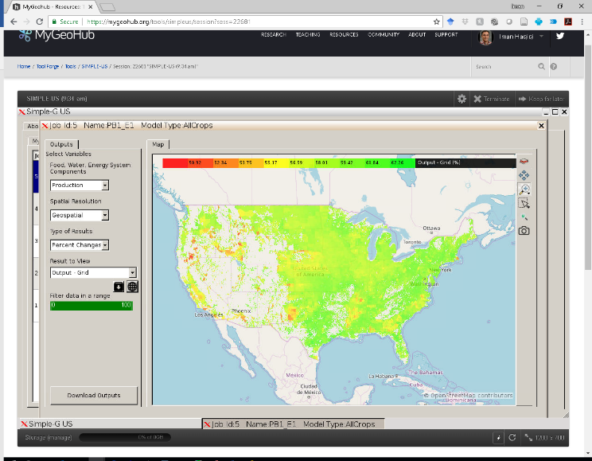

Cropland use by grid cell (2010)
I am going to make the following selections for the dropdown menus: land-> Geospatial -> Base Value -> Land Use –grid. Now click on visualize. This map shows the cropland use in the US which varies by grid cell ranging from 0 to 9 thousand hectares per grid cell. Note that green means high cropland use and red means small cropland use and white means no cropland. Considering that maximum land area of a grid cell is around 10 thousand hectare, there is less room for land expansion in some locations (green color), while more expansion is possible in other locations (red areas). This could explain part of the differences in production growth.
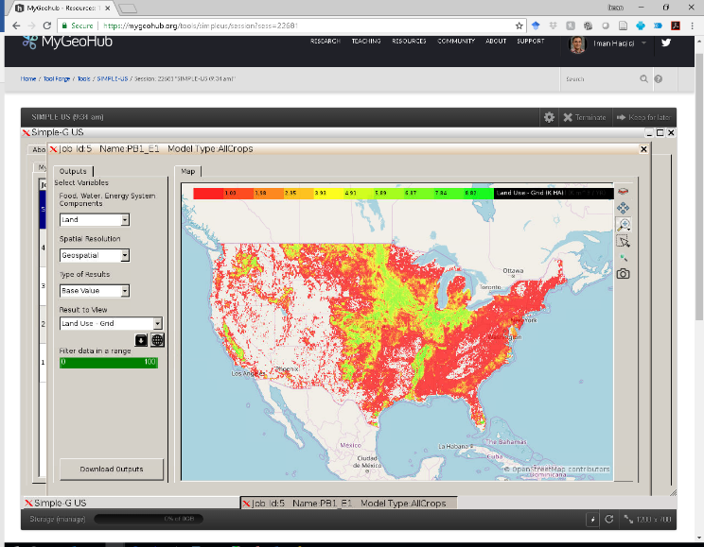

Percentage change in land use by grid cell (2010-2050)
Let’s take a look at projected cropland expansion by 2050. I am going to make the following selections for the dropdown menus: land-> Geospatial -> Percentage Change -> Land Use –grid. Now click on visualize. You see that percentage change in cropland use varies by grid cell ranging from 0.0 to 16.5% and suggesting higher growth on the marginal land.
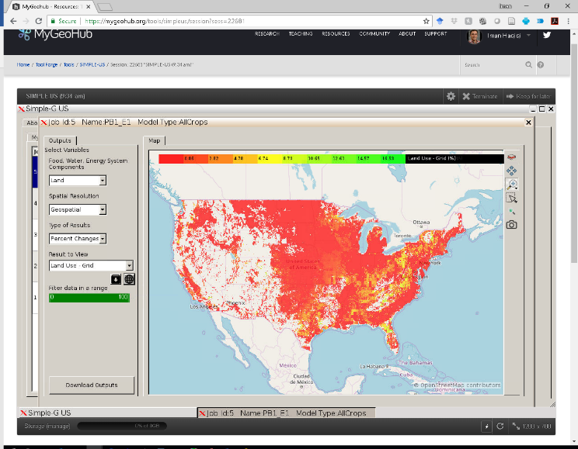

Water use by grid cell (2010)
Now let’s take a look at the water. Please make the following selections for the dropdown menus: Water-> Geospatial -> Base Value -> Water Use - Geospatial. I am also going to filter the range from 0-95%. Now click on visualize. This map shows water use by 2010 and showing high water withdrawal in green color.
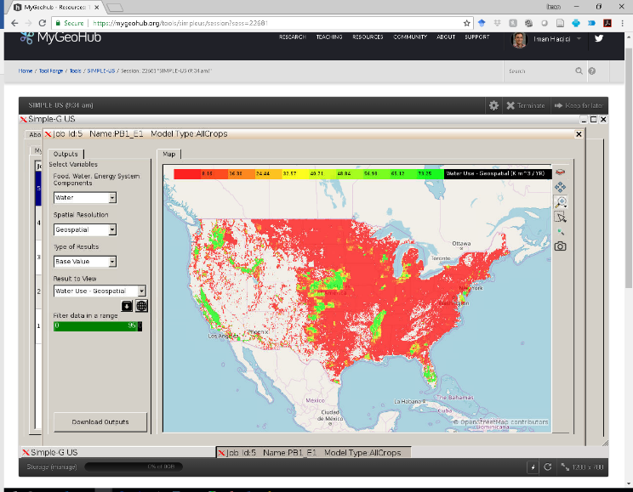
It seems that production growth is slower in areas with currently high water use.

Percentage change in water use by grid cell (2010-2050)
Now let’s take a look at the change in water use. Please make the following selections for the dropdown menus: Water-> Geospatial -> Percentage Change -> Water Use - grid. Now click on visualize. This map shows the percentage change in water use by 2050 and suggesting slower growth in water withdrawal in the western United States.

I will stop here. Feel free to contact us if you have any questions. And thanks again for listening.

